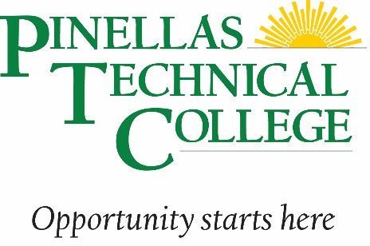

**Dual Enrollment Programs at PTC St. Pete**

**2022-2023 Academic year**

|  |  |
| --- | --- |
| **Program Name** | **Enrollment Year** |
| Automotive Collision Technician | Junior or Senior |
| Automotive Service Technology 1 | Senior |
| Building Trades and Construction Design | Junior or Senior |
| Cosmetology (secondary course codes) (fills quickly) | Senior |
| Digital Video Production | Junior or Senior |
| Drafting | Junior, 2nd semester |
| Electricity | Junior or Senior |
| EMT (specific pre-reqs required + 17 years old) | Senior |
| Facials Specialty (secondary course codes) (limited seats) | Senior |
| Heating, Ventilation, Air Conditioning/Refrigeration 1 | Junior or Senior |
| Medical Administrative Specialist (limited seats) | Junior or Senior |
| Network Support Services (limited seats) | Junior or Senior |
| Pharmacy Technician (2.5 GPA + 17 years old) | Senior |
| Plumbing | Junior or Senior |
| Practical Nursing (2.5 GPA + 17 years old) | Senior |
| Professional Culinary Arts and Hospitality | Junior or Senior |
| Welding Basic (limited seats) | Senior |

**Qualifications for dual enrollment:**

* **16 years of age**
* **Unweighted GPA of 2.0 (exceptions noted above)**
* **On track for graduation**
* **Application must come from high school counselor**
* **Students must take the required admissions test at our campus unless they have a record of ACT, SAT or PERT scores in Reading, Math and Language/Writing/English**